**Workshop 3, 4, 5**

**Q1**. Users are required to enter two numbers of types “double”: ‘a’, ‘b’ using the keyboard (STDIN). Here, ‘a’ and ‘b’ are side lengths of a rectangular.

Please print out the area of the rectangular with 2 decimal places.

Below is an example of how the program will run:

Enter the values 1.55 for ‘a’, 2.67 for ‘b’.

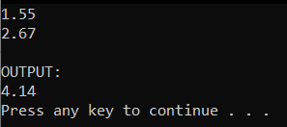

**Q2**. Users are required to enter five integer numbers using the keyboard (STDIN).

The program needs to find the minimum even number among the entered values. The program then displays this number on screen.

Below is an example of how the program will run:

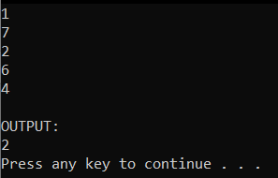

**Q3**. Your program allows users to enter 5 “integer” numbers.

The system sorts the entered numbers in ascending order. The system then displays only the even numbers to screen. There is a newline character between any two adjacent numbers.

Below is an example of how the program will run:

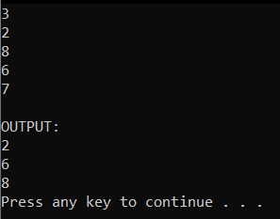

**Q4**. Your program allows users to enter a string: ‘s’ with maximum length of 100 characters. The system finds the number of words starting with letter 'h' and ending with letter 'g' in ‘s’. Finally, the system prints out that number.

Below is an example:



**Q5**. Your program allows users to enter array of n integers, where n is entered by the user (n < 10).

The program removes all duplicated odd numbers (keeps only the first occurrence of the numbers).

Then, the program prints the resultant list of numbers (after removing the duplicated ones). Between any two numbers, there is a newline character.

Below is an example how the program works.

